Ldap authentication in Linux server

1. Kindly check ldap port is listening or not from Linux server.

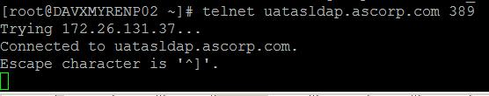

2. Add LDAP sever details in /etc/hosts file.

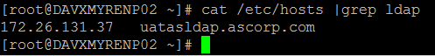

3. Install samba and samba-winbind packages



4. Add entries as below in krb5.conf file

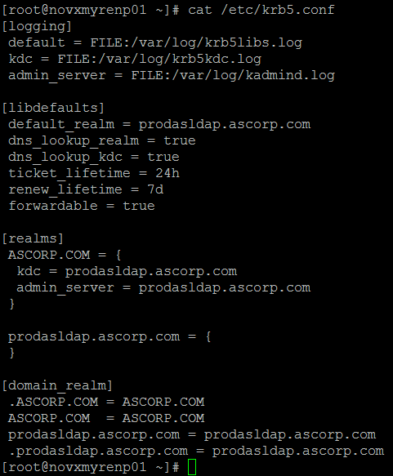

5. Add Winbind in nssswitch.conf file as below

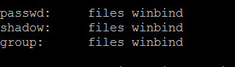

6. Add below configuration in samba configuration /etc/samba/smb.conf

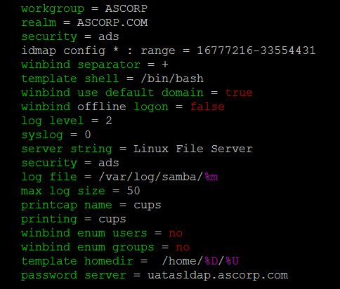

7 start samba services and enable on boot.



8. Add Linux server using below command. Give your network id password

net ads join –U toduanil

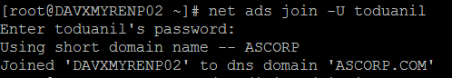

9. Enable Winbind option in authconfig-tui

Select “Use Winbind” in user information and select “use Winbind Authentication “ in authentication field as below.

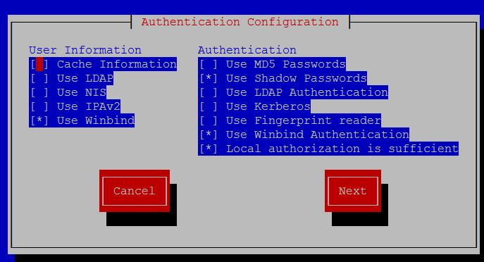

10. Click ok button

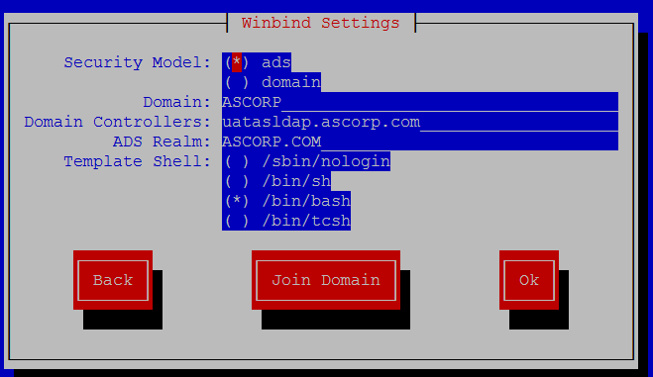

11. Once enter ok button, Winbind services will start automatically



12. Finally check authentication using your network id.

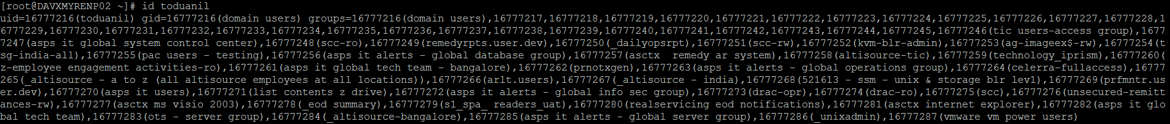

13. Create mysql file /etc/pam.d as below

